**CountryEdu Private Limited**



Report

On

**INVENTORY MANAGEMENT SYSTEM**

By Adnan Habib

Table of Contents

1. ABSTRACT 3

2. INTRODUCTION 3

3. HOW INVENTORY MANAGEMENT SYSTEMS HELP BUSINESSES 4

3.1. MAXIMIZE PROFITS AND REDUCES LOSS 4

3.2. IMPROVES EFFICIENCY 4

3.3. KEEP CUSTOMERS HAPPY 4

4. ADVANTAGES 5

4.1. REDUCING INACCURACIES 5

4.2. ENHANCED PRODUCTIVITY IN OPERATIONS 5

4.3. NO MORE MANUAL WORK 5

4.4. COST-SAVING 5

4.5. DATA SECURITY 6

5. DISADVANTAGES AND DRAWBACKS 6

5.1. BUREAUCRACY 6

5.2. IMPERSONAL TOUCH 6

5.3. INCREASED SPACE IS NEED TO HOLD THE INVENTORY 7

5.4. COMPLEXITY 7

5.5. HIGH IMPLEMENTATION COSTS 7

5. CODE IMPLEMENTATION 8

3. CASE STUDY MCDONALD’S – CODE IMPLEMENTATION 8

# 1. ABSTRACT

Inventory management is essential to keeping your business running smoothly. Inventory management involves having the right amount and type of inventory available to meet the needs of the company's suppliers and customers. It helps to maintain the right balance between the services provided by the company and its inventory.

Data analytics is the process of sorting through data sets in order to provide real-time and up-to-date information that can help a company succeed.

# 2. INTRODUCTION

What is Inventory Management System?

An inventory management system is a software program that helps businesses track and manage inventory, so they can optimize their stock levels. The system ensures product availability and ensures inventory is in the right quantity at the right time with minimal manual, paper or electronic processes. Efficient inventory management enhances the customer experience, improves cash flow and optimizes order fulfilment.

With the increasing demand for efficiency in the modern world, today's inventory management systems use data analytics to forecast future sales and trends. These systems use past data to anticipate future demand for inventory, and also help businesses understand customer behaviour, product performance, and channel performance. These systems help make data-driven decisions that can increase productivity and profitability in the business.

The systems provide a range of features to help retailers manage their inventory, sales, and returns. Analytics provides information about what's happening in your business, helping you make better decisions. It can show you:

* How customers are using your products or services, and how you're performing compared to your competitors.
* The need to keep a certain inventory level in order to satisfy customer demand while still meeting the minimum stock requirement.
* Optimization of stock management.
* Enabling cross-selling can help improve the sale of less demanding products.

# 3. HOW INVENTORY MANAGEMENT SYSTEMS HELP BUSINESSES

## 3.1. MAXIMIZE PROFITS AND REDUCES LOSS

By using past data to understand consumer trends, an inventory system can help a business owner make smarter and more profitable decisions when re-stocking products. The system prompts firms to rethink their business strategies. For example, using an inventory system recommendation, a company can ask questions such as "Is the item performing poorly because it is not being upgraded enough?" or "Is it because there is no demand for it?" By answering these questions, the company can understand whether or not it should continue to stock certain goods to increase profit and reduce costs.

## 3.2. IMPROVES EFFICIENCY

With the internet enabling anyone to start a business, businesses need to provide customers with a great experience without significantly increasing costs or compromising quality. As a company grows, its inventory levels increase, which can create challenges in maximizing efficiency. Inventory management systems consider all the factors necessary to create an efficient supply chain.

The inventory management systems use big data to help resolve overstock and improve order fulfilment. This system is designed to reflect current stock levels in real-time across all stores and suggest how many products to produce in each location. Likewise, the system can be designed to automatically ship once an order is placed. For example, once an online order has been processed, an inventory management system can automatically assign products to the warehouse closest to the customer's destination, resulting in faster delivery times.

## 3.3. KEEP CUSTOMERS HAPPY

When customers see out-of-stock items, their first instinct is to check other stores. This inability to supply stocks directly can have serious consequences for a firm because customers prefer convenience. Ultimately, customers want to buy the products where and when they want.Inventory management systems use past data to predict future trends, which will revolutionize how businesses operate with the recent breakthrough of electronic commerce sites.

# 4. ADVANTAGES

## 4.1. REDUCING INACCURACIES

A variety of internal management procedures make up inventory and stock management. There is a risk for errors while performing all of these activities manually, such as data duplication. When you use inventory management software, all data collection and tracking procedures are automated, leaving no room for error.

## 4.2. ENHANCED PRODUCTIVITY IN OPERATIONS

You can determine what products are selling rapidly through your business channels using analytics and data. This helps you decide to make wiser business selections and you could see a pattern. Example: Do you have to handle items and their expiration dates, for instance? This has implications for the health, cosmetic, and pharmaceutical industries. Stunning, no? This is feasible with effective stock management.

## 4.3. NO MORE MANUAL WORK

When working manually, you are more likely to commit mistakes or, maybe more accurately, human errors. You shouldn't perform such difficult computations by yourself. You will waste a lot of man hours without inventory management software. The group will keep track of the things utilised in each transaction and other details. These chores may be readily and effectively completed for you by inventory management software.

## 4.4. COST-SAVING

With the use of an inventory management system, deadstock and overstock issues may be avoided. Inventory management mistakes can result in lost sales, excessive spending, etc. When you streamline your inventory management, you not only cut out the stock costs brought on by human error, but you may also turn a profit by making additional cost reductions. You may also figure out how much safety stock you have! Most significantly, it can retrieve your product history so that you can replenish your inventory and manage it appropriately.

## 4.5. DATA SECURITY

You can impose user restrictions in the inventory management system in accordance with your needs. Every user can be restricted and given permissions so that errors don't occur. The main advantage is that it offers security at all levels. For example: If everything is in the right sequence, a worker may write data about objects and the manager will approve them.

In general, you may provide a user the authority to determine which data they can access and see. There is no possibility of data loss or leaking because each user is restricted.

# 5. DISADVANTAGES AND DRAWBACKS

## 5.1. BUREAUCRACY

Despite the fact that inventory management enables staff members at all levels of the organisation to see and alter corporate stock and product inventory, the infrastructure needed to create such a system adds an additional layer of bureaucracy to the process as a whole and the business as a whole. This includes the amount of new personnel who are not present to manage the warehouse and enable transactions in situations where inventory control is done internally. When inventory management is outsourced to a third party, there is a membership fee involved and a reliance on a different organisation to handle infrastructure management.

Whatever option you select, it will result in more overhead costs and more administration layers between the business owner and the client. From the perspective of the consumer, it will take more time until a problem is resolved if top management is involved.

## 5.2. IMPERSONAL TOUCH

The absence of a human touch is another drawback of inventory management. Although the availability of products is increased globally thanks to large supply chain management systems, and the majority of them offer customer support in case of problems, the increase in infrastructure can frequently mean a loss of the distinctive personal touch that makes a business stand out from the competition.

Another disadvantage of inventory management is the lack of human interaction. Large supply chain management systems have increased product availability globally, and the majority of them provide customer support in the event of issues, but the increase in infrastructure can frequently mean a loss of the distinctive personal touch that sets a business apart from the competition.

## 5.3. INCREASED SPACE IS NEED TO HOLD THE INVENTORY

Unless the products you deal in are really tiny in size, you will need a warehouse to keep your inventory since you need to have space to hold it. In addition, you will require workers, forklifts to transport the stock, and shelves and racks to store your products. Even with a high amount of inventory, a company may still need to keep a lot of items, which requires storage space and perhaps additional operational expenses. As a result, costs will rise, which will have a negative effect on how much money the company makes.

## 5.4. COMPLEXITY

Some inventory management techniques and procedures might be intricate and challenging for personnel to comprehend. Employee training may be required as a result so they can understand how the system operates. A periodic examination of all products is required by some inventory management systems, such as the fixed order period method. The system is somewhat less effective as a result of this.

## 5.5. HIGH IMPLEMENTATION COSTS

Because the firm must install specialised equipment and software in order to use them, certain inventory management systems can be expensive. This may be a concern for huge companies that operate in challenging environments. Even once the pricey system is installed, frequent maintenance and upgrades are still required, adding to the overall cost.

# 5. CODE IMPLEMENTATION

Simple implementation of Inventory Management System using python and using pandas and matplotlib libraries. Few methods included are:

* Display Inventory Stock using a graph
* Display Revenue for the items purchased using graph
* Update Items in Inventory Stock
* Purchase Item from Inventory Stock

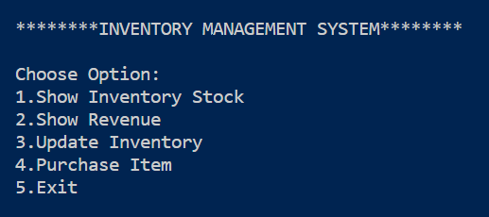

Dataset used is **InventoryData.csv** from Kaggle. Dataset include two columns, Item name and it’s Quantity.

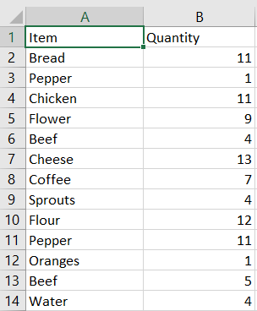

Purchased items and the revenue generated by it is stored in separate data file called **PurchaseData.csv**, which include four columns - Items, Quantity, CPU (Cost Per Unit), and Revenue Generated.

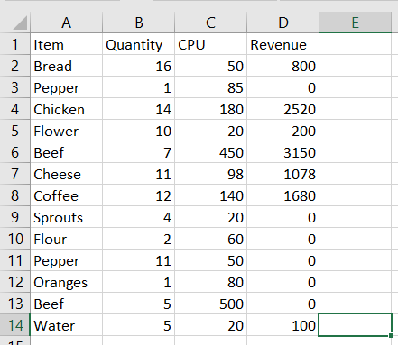

**Method 1:** Displaying Inventory Stock using Bar graph.

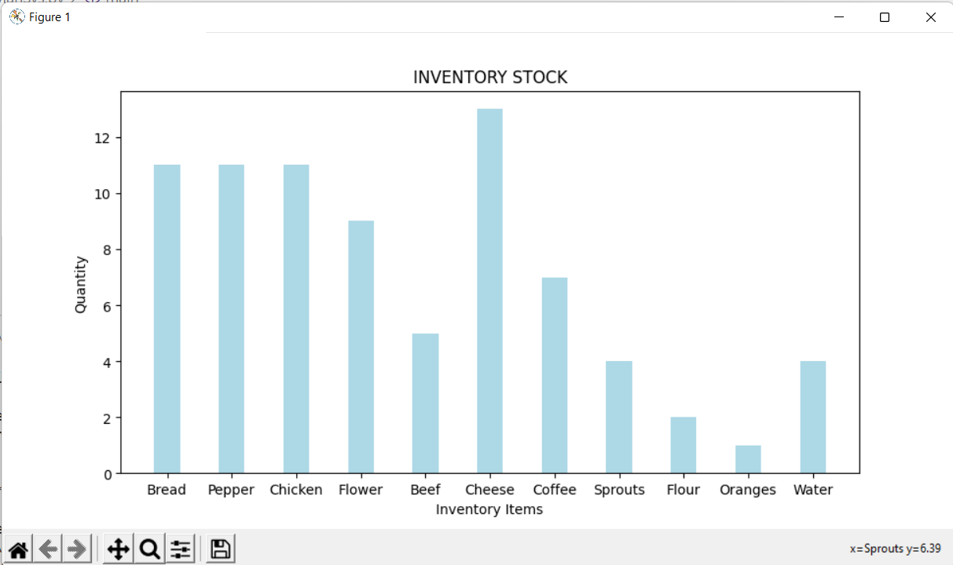

**Method 2:** Displaying Revenue Report of the items purchased from the Inventory Management System.

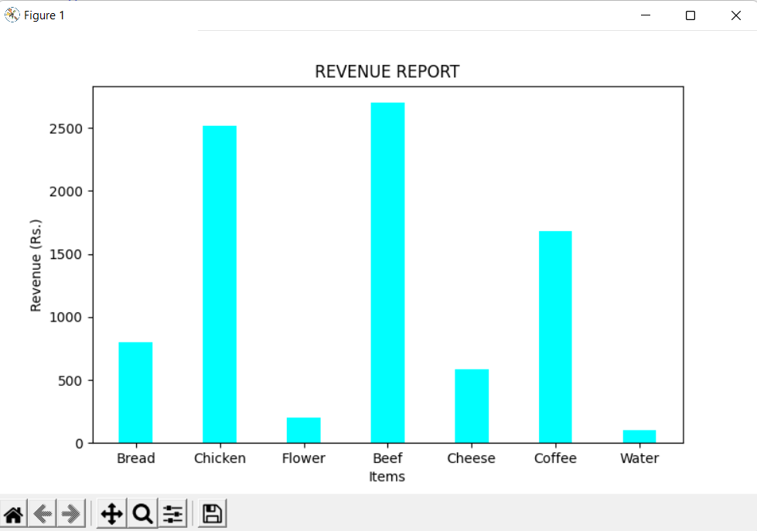

**Method 3:** Updating Item information in Inventory Stock. Item name is entered and its quantity that needs to updated is entered and the data is updated into the inventory stock.

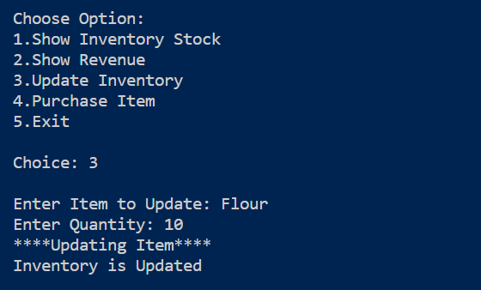

**Method 4**: Purchasing item from the Inventory by simply entering item name and the quantity that needs to be purchased.

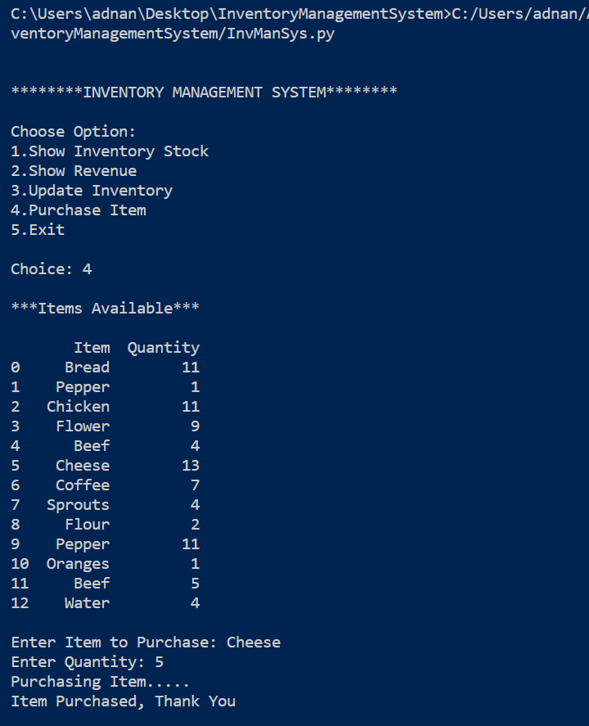

GitHub Link: [Adnan232/McDonalds-Market-Segmentation-Analysis (github.com)](https://github.com/Adnan232/McDonalds-Market-Segmentation-Analysis)